How to use Zoom app
In order to join a video conference using the Zoom program, select the option you need:
• How to run Zoom on a computer
• How to run Zoom on the phone
How to run Zoom on a computer
1. Open the lesson link in email or WhatsApp:
The link usually looks like this: https://us04web.zoom.us/j/8735786140
- Either click on the link in the email or in the WhatsApp window on the computer.
2. If this is your first time using Zoom, clicking on the link in the browser will open such a page:
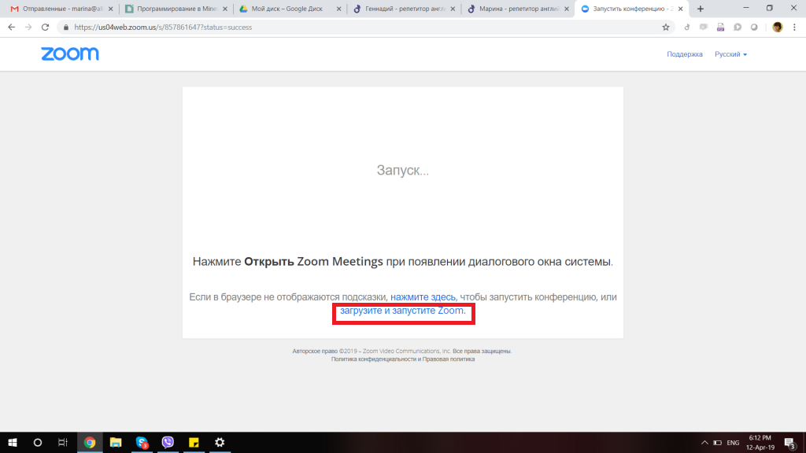
Click on the blue Download link and Launch Zoom.
ATTENTION!!! On the Macbook, there is a difficulty at this step when the page does not have a “Download Zoom” button and it is proposed to open the conference in a browser. Then use this download link: https://zoom.us/download
3. The browser will automatically try to download the program and it will appear in the download window.
- In some cases, the computer may decide that the file is suspicious, then you need to let it download the file anyway:
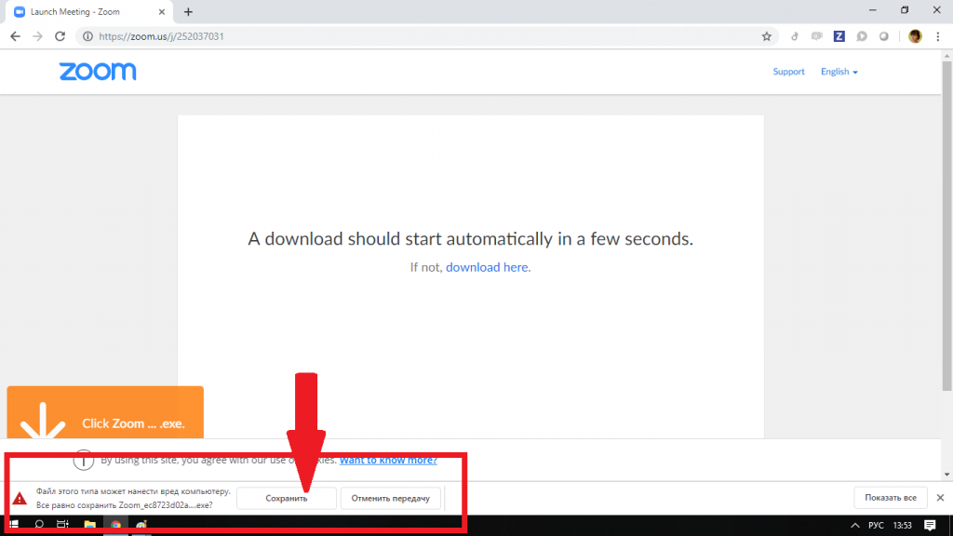
- If everything is in order, the file will be downloaded (just a few seconds) and will appear in the download window. Click on it:
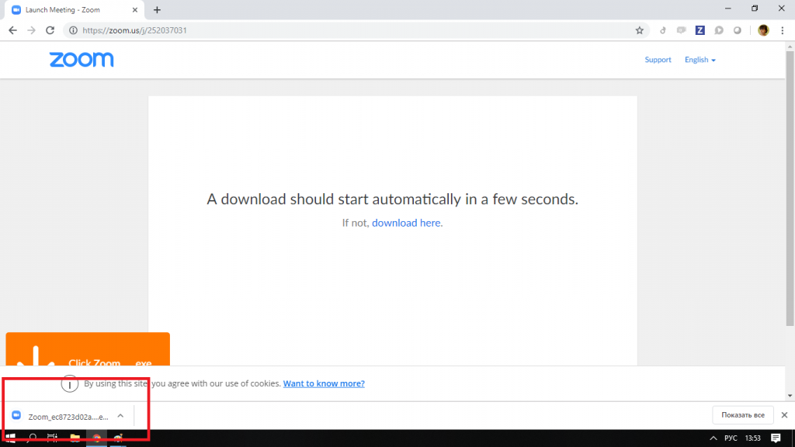

4. Run the file.
- Sometimes the computer asks for permission to make changes to the system, let it do it:
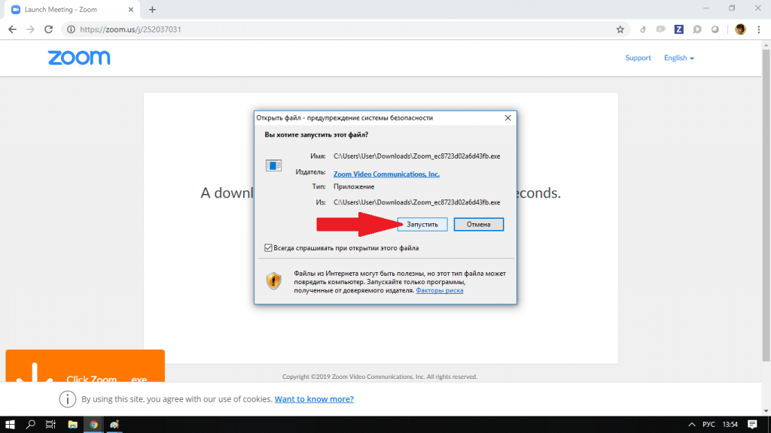
- If everything is in order, the program will start the installation, just wait:
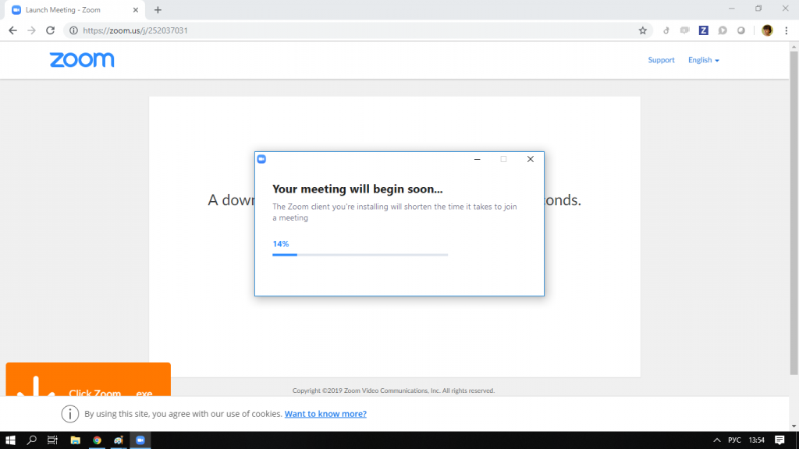

5. When the download is finished, enter the name in the window (the student’s name is better, so that the teacher understands). Click "Join Conference":
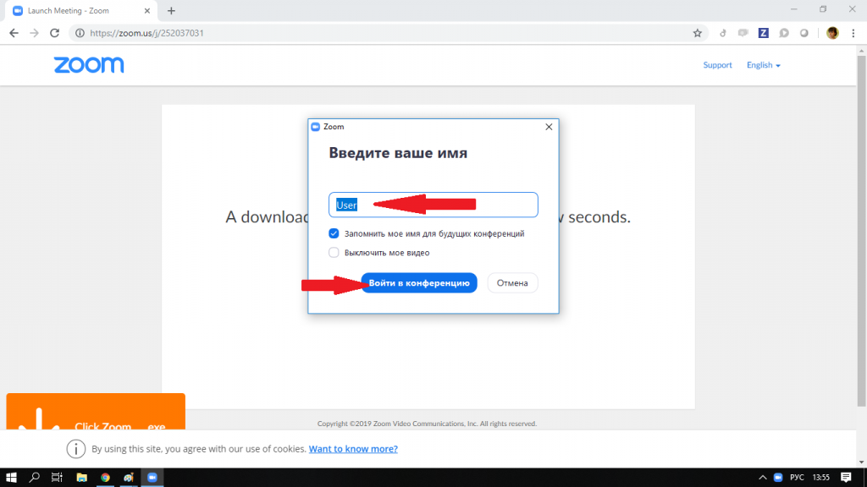
6. Click on the green button “Log in using computer sound”.
To prevent such a request from appearing in the future, you can check the box “Automatically enter audio conferencing from a computer”. However, you can not press this yet, it's okay.
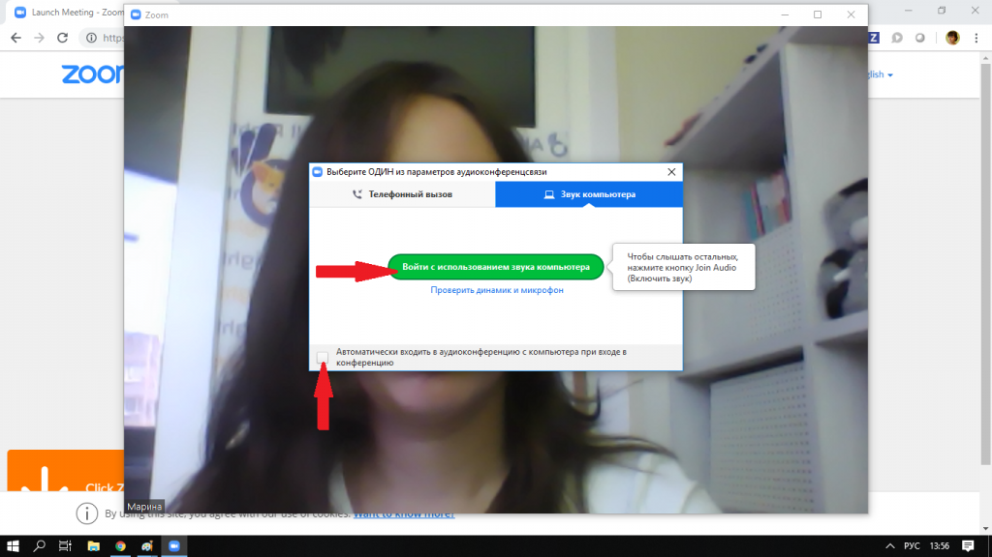
7. After that, you will immediately go to the lesson:
7. If you see a window like below, then you entered too early and you just have to wait a bit:
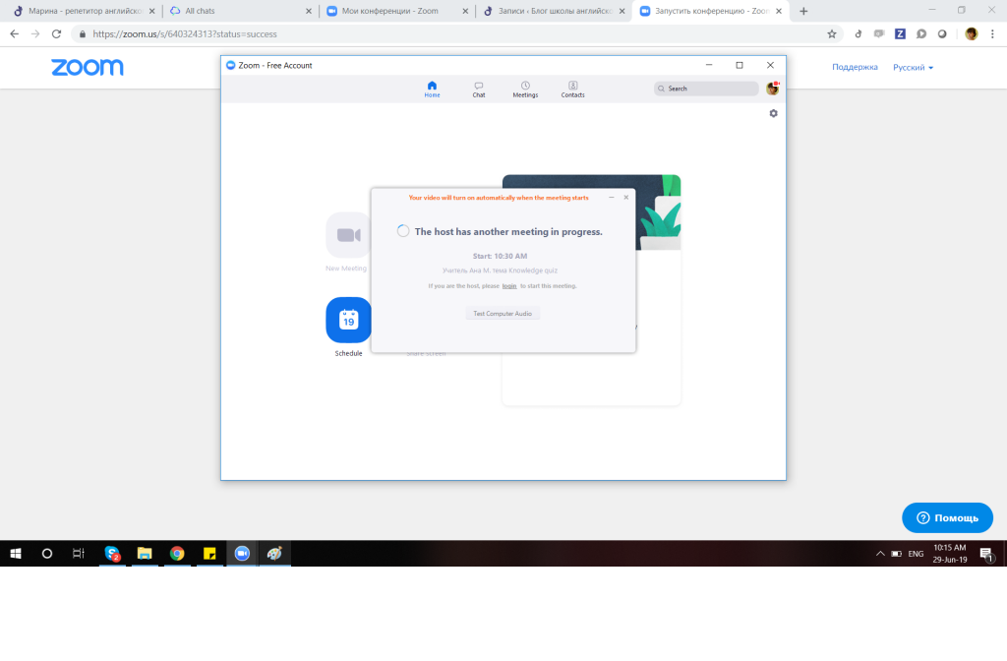
We wish you interesting lessons!

How to run Zoom on the phone
1. Open lesson link in email or WhatsApp:
Link usually looks similar: https://us04web.zoom.us/j/8735786140
Either click on the link in the email or in the WhatsApp window on your phone:
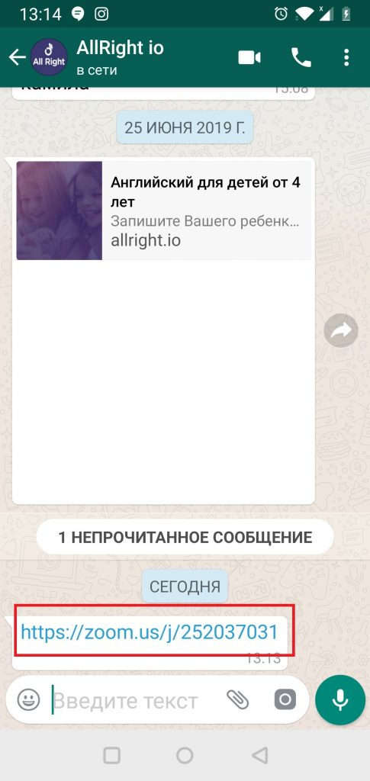
2. If this is your first time launching Zoom on your phone, the Zoom website page will open in your browser offering to download the program.
Click on the “Download” button as shown in the picture:
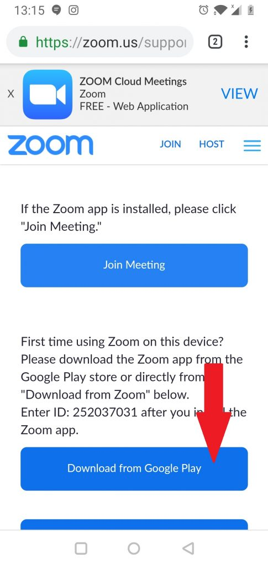
3. In the window that opens, select "Install":
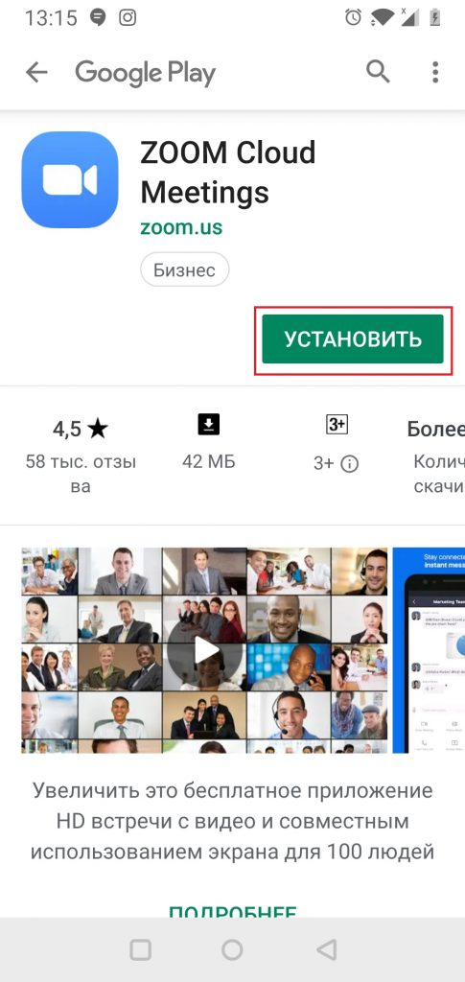
4. The program will start loading, wait a bit:
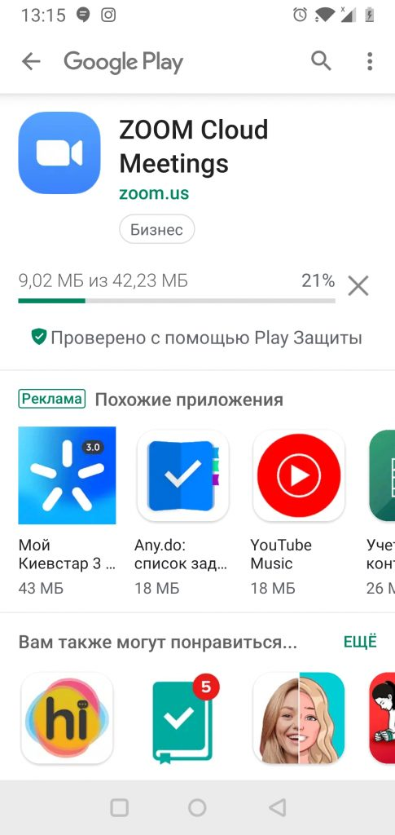
5. Click “Open” to start Zoom:
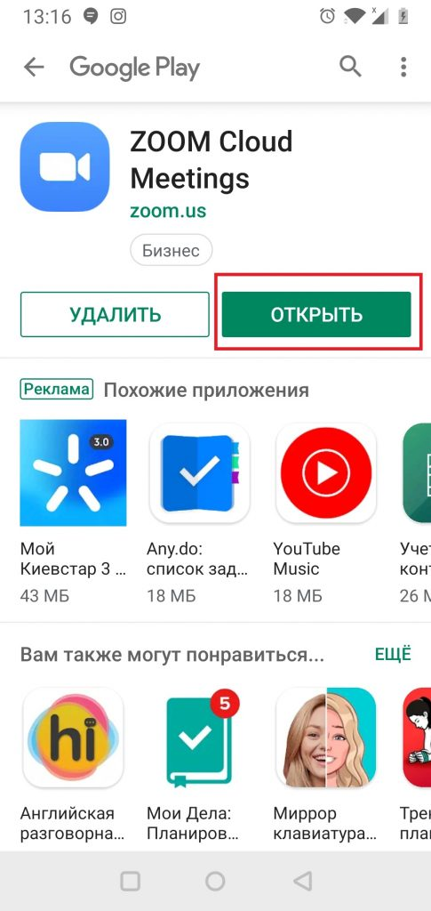
6. The Zoom window opens. Do not click anything, roll it:
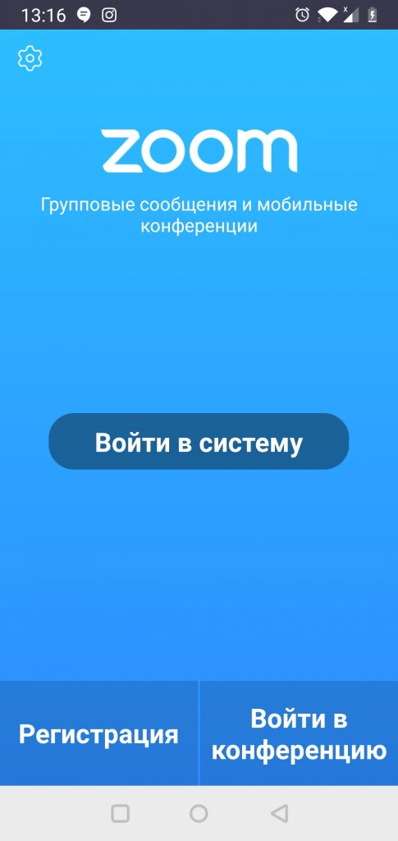
7. Return to the link that you received in step 1 of this instruction and click on it again:

7. Select “Zoom” to launch:
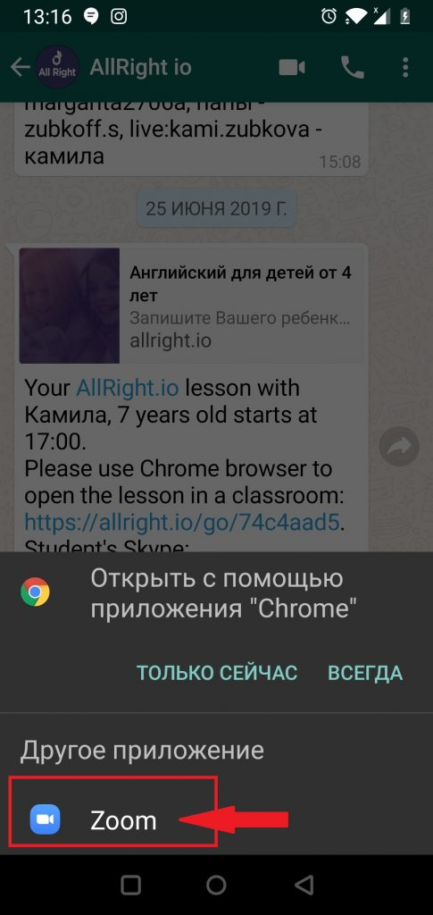
7. Enter a name in the window (better name, so that the teacher understands). Click OK:
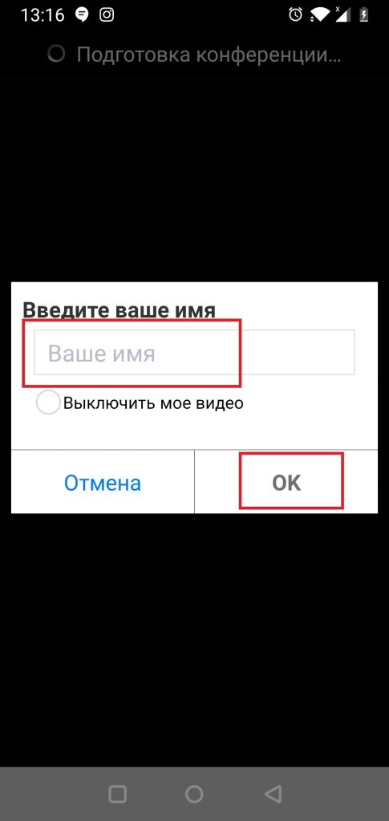
8. Now the system will warn that it needs access to the microphone and camera. Click "Clear":
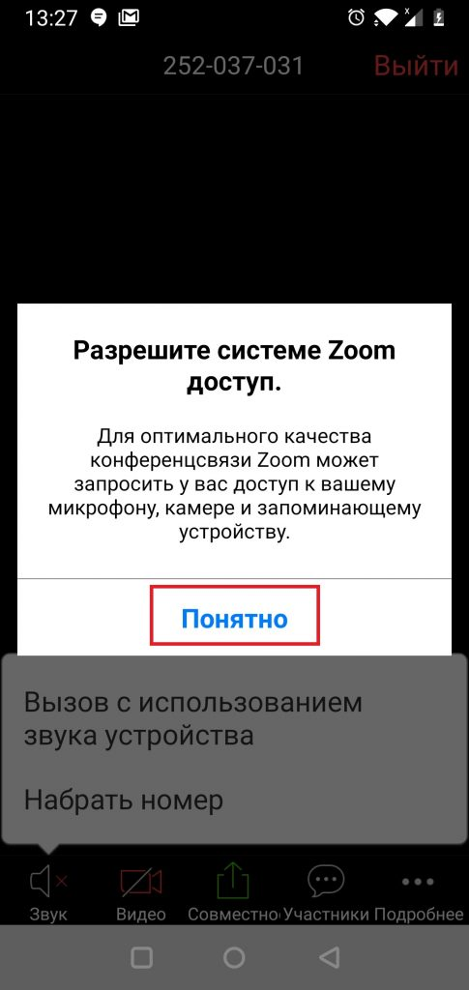
9. Allow the system access to the microphone:
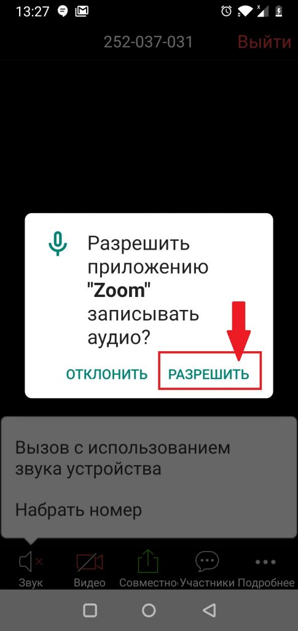
10. If you later want to temporarily mute the microphone in the lesson, pay attention to the microphone icon at the bottom. Normal - works, crossed out - does not work:
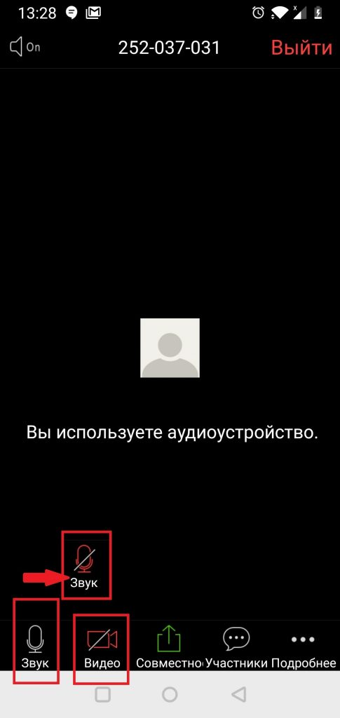
11. Click on the camcorder icon to turn it on (see screenshot above).
12. Allow access to the camera:
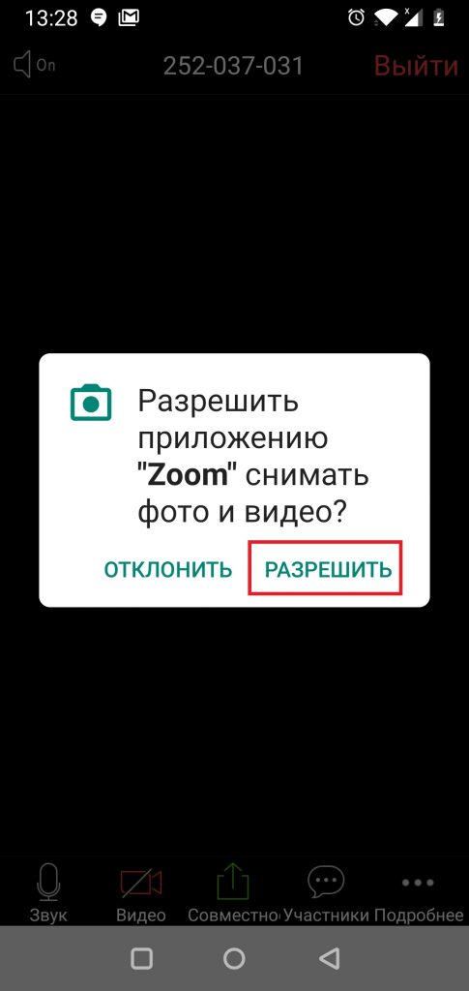
13. You will immediately get to the lesson:
We wish you interesting classes
Source Author: 12.04.2019 ~ Marina
https://allright.com/blog/ru/2019/04/12/zoom/

