How to view the course information
This article is intented for students.
Information about the course can be found in the feed. If the teacher has added this information, the following information will be available to you: topic, class number, and course description.

On the computer
- Go to classroom.google.com.
- Select a course feed.
- Click the down arrow below the image.
- To close the course information, click the up arrow.

On Android device
- Open the Google Classroom app .
- Select a course, click on the «Feed» icon.
- Click on the «Information» icon in the upper right corner .

On iOS device
- Open the Google Classroom app .
- Select a course click on the «Feed» icon .
- Click on the «Information» icon in the upper right corner.
Was this information helpful?
Yes

How to join the course as a student
To use the Class, log in to the service from a computer or mobile device. After that, you will be able to join the courses, receive assignments and communicate with other students. If you join the course on one device, you’ll be signed in on all of your devices.

How to join the course
There are two ways to join the course:
• Indicate a special code if the teacher reported the code in the classroom or sent it by e-mail.
• Accept the invitation from the teacher. If the teacher has sent an invitation, on the Classroom homepage, on the course card, click Join.
Forgot or lose course code? If the code does not work?
If you have deleted, lost or forgotten the code, ask the teacher to resend it or create a new one. If the code is invalid, also contact the teacher for help.
Note. The code is used only once to join the course: it will not be required after.

Join the course
Computer, Android, IOS.
To join the course, you must enter the Class. Learn how to sign in.

How to join the course using the code
- Go to the page classroom.google.com.
- At the top of the page click add Join the course.
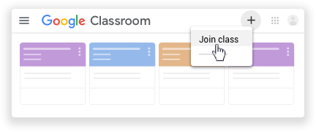
- Enter the course code received from the teacher and click Join.The code consists of 6-7 letters and numbers. Example: hjhmgrk or g5gdp1.
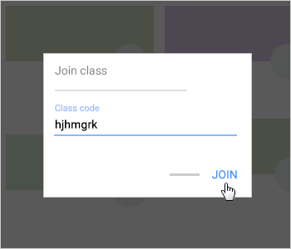

How to accept an invitation from the teacher

Go to the page classroom.google.com.
- On the course card click join.
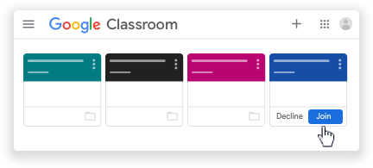

Note. Only the teacher can change the image of the course. However, you can change your profile photo in the Classroom. Learn more…

How to view the list of assignments on the course

This article is intented for students.

You can view your course assignments in several ways:
• View the assignments you need to take on the Courses page.
• View all the work of the course on the page "My work".
• Filter course assignments on the Incomplete page.
• View the latest assignments in the feed.
• View assignments sorted by topic on the Assignments page.
Computer, Android, IOS.

How to view current tasks
On the "Courses" page on the course card, you can see the tasks that need to be completed within a week. You will see the name and deadline for a maximum of three tasks.
- Go to page classroom.google.com.
- To view detailed information click on the task name.
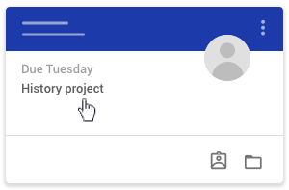
How to view all your assignments on the course

You can see the list of all tasks on the page "My work". In addition to the tasks, the dates for their implementation and evaluation are also indicated, and you can see what work still needs to be completed. Also, the work can be filtered by selecting the assigned, with the missed deadline or returned with an estimate. If necessary, you can see additional information, such as comments and attachments.
- Go to page classroom.google.com.
- Choose one of the options:
  - On the course card click on the icon.
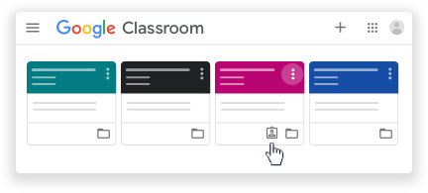
  - Choose course Task Open your profile.
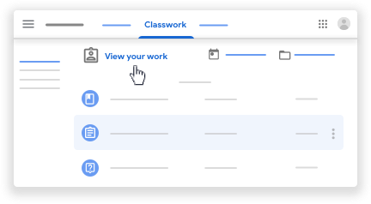
- If necessary, you can see the attached files, comments and other details of the task or question. To do this, click on the name of the desired work More.
- To sort the work, in the "Filters" section, select the status you need: Assigned, Returned with Evaluation, or Deadline Passed.
How to filter class assignments
On the Incomplete page, you can filter by course and see the following task categories:
• Failed: scheduled assignments that you have not completed yet. The tasks will be divided into groups, for example: those that need to be completed today, within a week or later, without a deadline and with a deadline already passed.
• Completed: Completed assignments that you have passed. The list contains information about the assignment (for example, delivered on time or late), as well as an evaluation (if any).
To view your assignments:
- Go to page classroom.google.com.
- Click on icon Incomplete.
- To sort the tasks by course, click All courses and select the course.
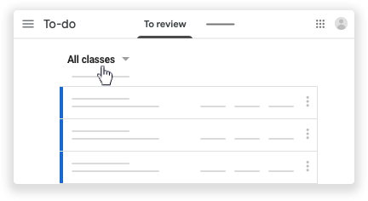
- Click on the name of the task.
- To view the task that you have already passed, in the Completed section, click on the title of the desired task.
If the assignment has already been checked by the teacher, an assessment will be evaluated.
View recent assignments and announcements
You can see the latest assignments and announcements in the feed. Recent posts are always at the top of the feed.
- Go to page classroom.google.com.
- Select a course.
- To view instructions or comments, click on the task title or question.
How to view assignments by topic
On the Assignments page, a teacher can organize assignments by topic, such as Homework or Essays.
- Go to page classroom.google.com.
- Select a course.
- At the top of the page click Tasks.
- Under the subject you will see a question icon or a task .
- Click on a post to view instructions or comments Select view task or show a question
Was this information helpful?

How to answer a question
This article is intented for students.
The teacher can publish two types of questions: with or without an answer options. In the second case, the student himself enters the answer. If the question has answer options, the student selects the desired option. If the teacher allows, then by sending an answer, you can see the answers of other students.
Before answering a question, read the instructions or attached files. Additional content, such as files from Google Drive, links, or YouTube videos, may be attached to the question.
You can view and answer questions on the Tasks page or in the feed.
Computer, Android, IOS

On the Tasks page

How to give a short answer to the question
- Go to page classroom.google.com.
- Select a course open a Task page.
- Click on a question to read it and see all instructions or attached files.Note. You may need to click Show Question.
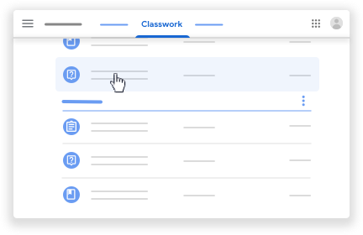
- Answer the question in the answer field click submit. If confirmation is required, click submit.
Note. The submit button is activated after you select the answer.
- If you want to add a comment on the course, click on add a comment. Type the text click on publish.
- To add a comment or a question that will be visible only to the teacher, click on the question add a personal question.
Enter the text click publish.
How to choose an answer from the list
- Go to page classroom.google.com.
- Select a course Open a Task page.
- Click on a question to read it and see all instructions or attached files.Note. You may need to click Show Question.
- Select an answer, click Submit. To confirm, click Submit. Note. The Submit button is activated after you enter the answer.
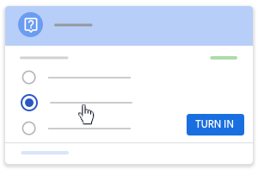
- If you want to add a comment on the course, click on add a comment. Enter the text click publish.
- To add a comment or a question that will be visible only to the teacher, click on the question add a personal question.
Enter the text click publish.

View and comment on students responses
You can see and comment on the answers of other students if:
• the question requires a short answer;
• The teacher authorized to perform these actions.
- Go to page classroom.google.com.
- Select a course open Task page.
- Click on the question.Note. You may need to click Show Question.
- Click on responses of other students.
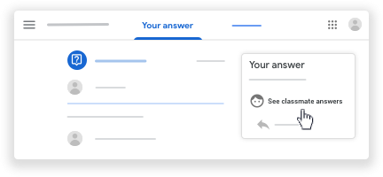
- If you want to comment on a student's response, click reply enter text click publish.

How to change your response
You can see and comment on the answers of other students if:
• The question requires a short answer;
• The teacher authorized to perform these actions.
- Go to page classroom.google.com.
- Select a course open the Task page.
- Click correct.
Note. You might need to select Show question Correct.
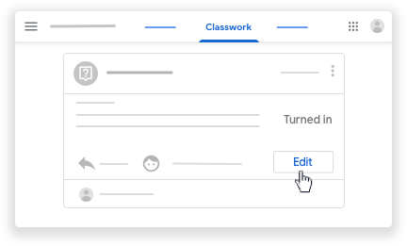
- Add corrections click submit .

In news feed

How to giv a short answer to a question
- Go to page classroom.google.com.
- Select course.
- On the Feed page, read the question and read all the instructions or attached files.
- Answer the question in the answer field click submit. If a confirmation message is displayed, click submit.Note. Submit button is activated after you enter the answer.
- If you want to add a comment on a course, click add a comment. Enter text click publish.
- To add a comment or a question that will be visible only to the teacher, click on the question add a personal question.
Enter the text click publish.

How to choose an answer from the list
- Go to page classroom.google.com.
- Select course.
- On the Feed page, read the question and read all the instructions or attached files.
- Answer the question in the answer field click submit. If a confirmation message is displayed, click submit.Note. Submit button is activated after you enter the answer.
- If you want to add a comment on a course, click add a comment. Enter text click publish.
- To add a comment or a question that will be visible only to the teacher, click on the question add a personal question.
Enter the text click publish.

How to see and comment othe students responses
You can see and comment on the answers of other students if:
• the question requires a short answer;
• The teacher authorized to perform these actions.
- Go to page classroom.google.com.
- Select a course open Task page.
- Click on the question.Note. You may need to click Show Question. Click on responses of other students.

How to change your response
You can see and comment on the answers of other students if:
• The question requires a short answer;
• The teacher authorized to perform these actions.
- Go to page classroom.google.com.
- Select a course open the Task page.
Click correct.
Note. You might need to select Show question Correct.
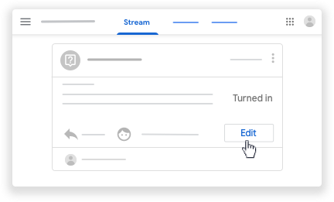

How to submit the completed task
Depending on the specific job, you can submit the document assigned to you by the teacher, create your own Google document or attach files to the assignment.

If you need to change an already submitted work, you can cancel its sending. Please note that if the task is completed or marked as completed after the deadline, it is considered to be sent late.

Computer, Android, IOS

How to submit the completed task
- Go to page classroom.google.com.
- Select a course Tasks click on a task.
- To attach the file:
  - In My work section, click add or create Click on the Google Drive icon, links or files .
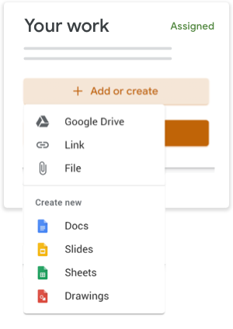
- Select a file or enter a URL for the link and click Add.Note. You cannot attach files you do not own.
- To attach new document:
  - In My work section, click add or create select «Documents» , «Presentations» , «Tables» or «Images» .
A new file will be attached to the work.
- Click on the file and enter the data. Note. You can attach or create multiple files.
- To delete an attached file, click on the icon next to it.
- If you want to add a personal comment for the teacher, enter the text in the Personal comments section and click on the "Publish" icon.
- Click Submit and confirm.
The status of the task will change to Completed.
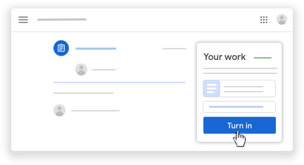

How to submit the task with the test
- Go to page classroom.google.com.
- Select course Tasks Click on a task.
- Open the form and answer the questions.
- Click Submit Mark as done and confirm.If, apart from filling out the form, nothing is required, the status of the task will change to Completed.
- If the task contains more than just a form, click Open Task.

How to submit a task with an attached document
If the teacher attached a document with your name in the title to the task, this is your personal copy for viewing and editing. The teacher will be able to track the progress of your work even before you click the Submit button.
- Go to page classroom.google.com.
- Select a course Tasks click on task.
- To open a file, click on the thumbnail with your name on it.
- Complete the task.
- Select the option you want:
• In the document, click Submit and confirm the action.
• In the Class task, click Submit and confirm the action.
The status of the task will change to Completed.
How to mark a task as a completed
Important! If the task is delivered or marked as completed after the deadline, it is considered to be sent late, even if you previously sent it for review on time.
- Go to page classroom.google.com.
- Select course Tasks select task.
- Optional: Leave a comment for the teacher in the Personal Comments section and click Publish.
- Click Mark as done and confirm the action.

The status of the task will change to Completed.

How to cancel the assignment
Important! If the task is delivered or marked as completed after the deadline, it is considered to be sent late, even if you previously sent it for review on time. If you canceled the assignment, do not forget to resend it before the deadline.
  - Go to classroom.google.com
  - Select a course Tasks click on a task.
  - Click Cancel Submit and confirm the operation. Note. Job submission will be canceled. Remember to resend it before the deadline.
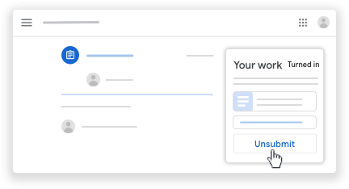

How to view tasks that are not submitted or submitted late
The teacher can set the deadline for the course. However, the Class allows you to submit the task late. When the teacher assigns the assignment, it is marked as Assigned. If you don’t pass the assignment or submit it late, it is marked as Missed deadline or Delivered late. For example, if the deadline is set at 9:00, work must be submitted no later than 8:59. Work submitted at 9:00 will be considered expired.
1. Go to classroom.google.com
2. On the course card, click on the icon.
3. Next to each object will be indicated the status of execution:
• Assigned: assignments set by the teacher. See their deadline.
• Completed: works that are delivered on time.
• With assessment: the work that the teacher evaluated and returned.
• Returned: Unrated assessments returned by the teacher are marked with.
• Missed deadline: works that are not delivered.
• Delivered late: works that are late.
4. To view additional information, click on an object, select Details.
Learn more about how to view the status of tasks and track their progress.

How a student can open his/her folder in Google Drive
This article is intented for students.
In your Google Drive folder, you can view, organize, and create files and folders. For example, you can create a Scientific Project folder and add files to it. If you work with other students, you can give them access to the folder.
You can open a folder in Drive both in the web interface and in the Class’s mobile applications.
Computer, Android, IOS
- Go to page classroom.google.com.
- Use one of the options below
  - On the course card click Open folder .
  - Select course Tasks Click on the folder Drive course.
You can find additional instructions for working with the Disk in Information center.

